**Making Payment with required Invoice Type Standard**

**Navigate to the required Invoice per screenshot below making sure all the required fields have been selected**

**Save after all the required**

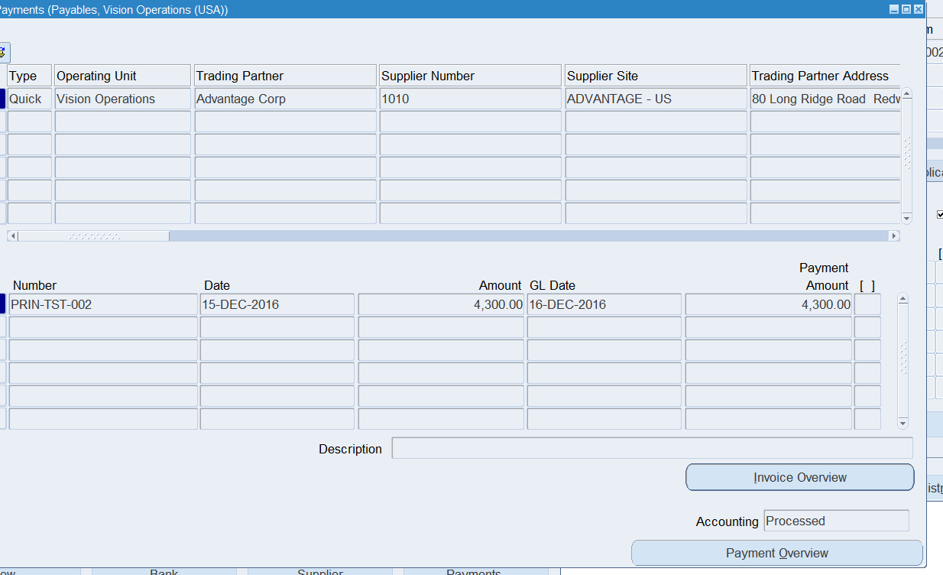

**Click the action tab and enter the details as per screenshot below. Select creating accounting and check out final post**

**Payment now processed per screenshot below**

**PAYMENT PROCESS REQUEST PER SCREENSHOT BELOW WITH ID=16072 GENERATED**

**Additional Payment confirming the Payment screenshots**

**Payment overview confirmation**

